|  |  |
| --- | --- |
| NAME | Muhammad Arslan Raza |
| ROLL# | 2020-EE-403 |

**Lab 4: Problem Set 2**

**Task 1**:

Write a program that takes two integers from user and determines and prints whether the first is a  
multiple of the second.

**Code:**

x=int(input("1st Number"))

y=int(input("2nd Number"))

if y%x==0:

print("first number is a multiple of second")

else:

print("first number is not multiple of second")

**Output:**

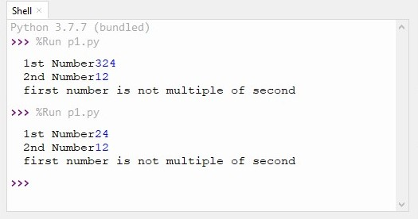

**Conclusion:**

Today I learn how to write a program that takes two integers from user and determines and prints whether the first is a multiple of the second.

**Task 2:**

Write a program that inputs three different integers from the keyboard, and then prints the sum,  
the average, the product, the smallest and the largest of these numbers.

**Code:**

x=int(input("enter 1st number"))

y=int(input("enter 2nd number"))

z=int(input("enter 3rd number"))

print("sum=",x+y+z)

print("product=",x*y*z)

print("average of three numbers=",(x+y+z)*0.3333333333)

if x>y>z:

print("first number is largest then both two numbers=",x)

else:

if x>z>y:

print("first number is largest then both two numbers=",x)

if y>x>z:

print("2nd number is largest then both two numbers=",y)

else:

if y>z>x:

print("2nd number is largest then both two numbers=",y)

if z>y>x:

print("3nd number is largest then both two numbers=",z)

else:

if z>x>y:

print("3nd number is largest then both two numbers=",z)

if x<y<z:

print("first number is smallest then both two numbers=",x)

else:

if x<z<y:

print("first number is smallest then both two numbers=",x)

if y<x<z:

print("2nd number is smallest then both two numbers=",y)

else:

if y<z<x:

print("2nd number is smallest then both two numbers=",y)

if z<y<x:

print("3nd number is smallest then both two numbers=",z)

else:

if z<x<y:

print("3nd number is smallest then both two numbers=",z)

**Output:**

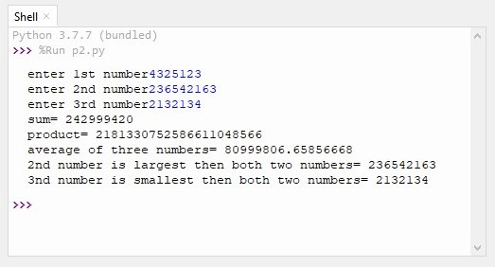

**Conclusion:** Today I learn how write a program that inputs three different integers from the keyboard, and then prints the sum, the average, the product, the smallest and the largest of these numbers.

**Task 3:**

Write a program that reads an integer and determines and prints whether it’s odd or even.

**Code:**

x=int(input("enter a integer"))

if x%2==0:

print("the input integer is even")

else:

print("the input integer is odd")

**Output:**

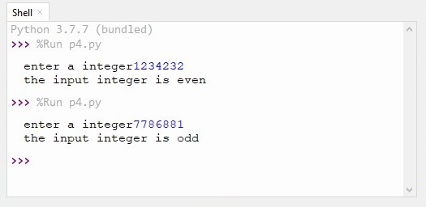

**Conclusion:** Today I learn how write a program that reads an integer and determines and prints whether it’s odd or even.